St John the Evangelist

Garden of Remembrance Policy and Procedures (July 2023)

Introduction

This document sets out how St John the Evangelist uses the memorial garden created in March 2107 as part of the church reordering project 2014-2017.
Rules and procedures for memorial gardens are set out in Diocesan guidance the Churchyard Plans and Records Regulations 1992 . Faculty approval for our garden was obtained in November 2016.
A Garden of Remembrance allows for the interment of ashes of loved ones. The garden is divided into 300x300mm plots within a grass lawn, without any individual identification of each plot, save for discrete grid markings at the edge of the interment area(s). The reason is to create an aesthetically pleasing environment for all.

A communal bench and area for displaying flowers is included in the garden. The area is conceived as a restful place, where people may sit in tranquility and reflect or pray.

The garden was blessed by Bishop Christopher on March 26th, 2017 and this policy was last approved by the Parochial Church Council, on 14th March 2017.

The Garden Area
Appendix E shows the plan of the area to the south of the church building which forms the garden of remembrance.

Records and Procedures
- The review and amendment of these rules are matters for the PCC.
- The garden is laid to grass, and individual plots or burial places are not marked. The reason is to create an aesthetically pleasing environment for all.
- Discrete markings on the edging stones reflect the grid pattern marked on the plan.
- The grid defines individual plots of 300x300mms (approx 1 foot square).
- Individual plots may be reused after 25 years without notification or consultation.
- A Book of Remembrance will record for each Interment: The Name of the Interred; Address; Date of Birth; Date of Death; Date of Interment; Plot Number
- The Book of Remembrance will be kept in locked display case or locked cupboard in the church office, together with a plan of the area. The plan will show which plots have been used and which are available for interment.
- Ashes should be interred in small untreated softwood caskets, to fit in a 200mm diameter hole. They may also be placed on the hole using a casket with an opening bottom.
- An Inscription will mark the entrance to the area as follows: St John’s Garden of Remembrance. To the Glory of God.
- Application for interment is via the Church Administrator (01926 853203 or admin@stjohn316.co.uk ) and at the discretion of the vicar.

Display in Church and Garden, Availability to Families and Undertakers
- A discrete notice in the Garden of Remembrance should read. “If you would like to know more about this Garden of Remembrance please contact the Church Administrator 01926 853203”
- A copy of this policy should be made available to undertakers and families seeking the interment of loved ones.

Flowers: Location and Removal
- Floral tributes may be placed in the assigned area in the garden. They may not be placed on individual plots.
- Artificial flowers, or objects are not allowed.
- Flowers will be removed when they appear to the maintenance team to have withered.
- Remembrance Day poppies and Christmas wreaths may be laid in the flower area at the appropriate times of year. Such wreaths and poppies may not be placed on individual plots
- These rules are designed to create and maintain an aesthetically pleasing and tranquil environment for all.
- All flowers, wreaths and poppies will be removed no more than 2 months after the commemoration.
- Bereaved families may also arrange via the church administrator to display flowers in church to mark anniversaries

Planned Capacity
- The planned area allows for 954 plots each of an area 300x300mms. Over a 25 year period, this provides capacity for 38 interments a year. We currently undertake some 12-15 funerals a year.
- Individual plots will be reused after 25 years.
- Where couples plan to share a plot, the first interment may be capped with a ceramic tile at the request of the family.

Charges
Charges are set and reviewed by the Church of England. Current fees are shown in Appendix D. Additional charges may be made by the PCC for heating of the church, the provision of a verger, and music. St John’s will charge the following additional fee: Heating the church (if required) £30, Steward £60. Music will only be charged if the services of an organist are required (£85)

³ https://www.churchofengland.org/weddings-baptisms-funerals/fees.aspx

Appendix A

The procedure for internment will include the following:

- Who to contact to request an interment.
- The booking of a day and time acceptable to family members.
- The provision of a celebrant to take the service of interment.
- Someone to remove an appropriate piece of turf for where the ashes are to be placed, and to replace it afterwards. (The sequence of turf removal in the Garden space to be defined for long term perpetual use.)
- The source of ashes. (eg Taylor's).
- How ashes will be made available at the time of interment.
- Who to pour them in.
- Disposal of container.
- Keeping the Garden tidy by cutting the grass.
- Entering details in the Book, such as full name, date of birth and date of death, in attractive calligraphy.
- Appropriate fees for any of the above and payable to whom.

Appendix B

Memorial Ground at St John the Evangelist, Kenilworth

The diocese publishes guidance on the requirements for churchyard memorials, which also includes a section on how cremated remains should be dealt with.

The area to be used for the interment of ashes should be large enough for the requirements of at least the next 25 years, after which it can be reused. This should be made known to any who intend to make use of the area. The permanent marking of particular plots is therefore not allowed.

The area to be used will be defined by the existing northern edge of the car park on its south side, and by the new path to the vestry on the north side, which is part of the alterations proposed in phase 2 of the church reordering project. The area will be defined by a kerb edging which will be marked at 300mm centres in order to allow individual plots to be defined. This is in line with the diocesan policy for the size of the plot.

Where couples wish to be interred together it is suggested that a ceramic tile be placed over the first interment.

With the layout presented the area could accept 954 interments with a 300x300mm plot size. Over 25 years this would allow about 38 interments per year. If the plot size was increased to 450x450 would allow about 25 interments per year. The location of particular plots will be recorded on a chart stored in the vestry, and a book of remembrance also records the dates of the individual.

Appendix C
Coventry Diocese Rules on Memorial Gardens

churchyard-regulations-v2.pdf (d3hgrlq6yacptf.cloudfront.net)

Appendix D
National Church of England Guidance on Charges
https://www.churchofengland.org/weddings-baptisms-funerals/fees.aspx

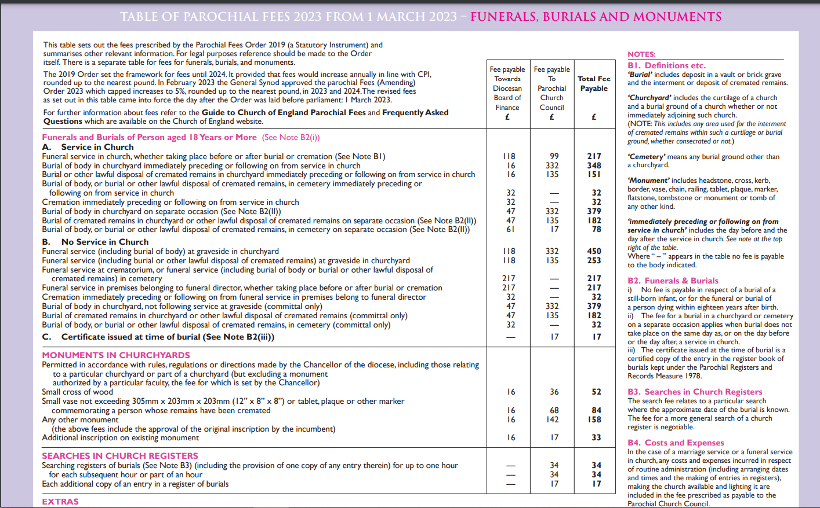

Appendix E - Plan of Garden
(being updated by Mark King)

Appendix F
St John the Evangelist, Kenilworth
Application for interment in the Garden of Remembrance
Details of the deceased:
Full Name
Address
Date of Birth
Date of Death
Family member for contact:
Name
Address
Telephone
Email
Details of undertaker:
Name of undertakers
Contact name
Telephone
Email
Details of the interment:
Date
Service details and timings
Celebrant
Ashes to be provided by
Container type (only biodegradable containers accepted)
Details of Remembrance Garden (Church Use):
Plot number
Ceramic tile topping required? (Y/N)
Plot to be shared with
Ashes to be poured in by
Disposal of container

https://d3hgrlq6yacptf.cloudfront.net/5f3ffda5728e0/content/pages/documents/churchyard-plan-1992.pdf
https://docs.google.com/document/d/1UP7hHHiGebkXRe-gS9ztHjRLPUjssd0Uu9L4qVLvGmA/edit?usp=sharing

