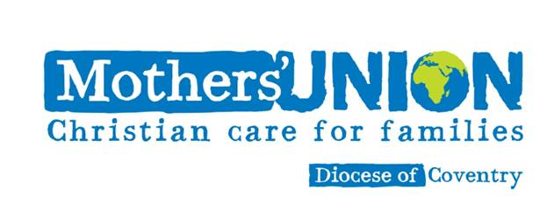**Mothers Union**

In 2024, Beryl Dayus retired as branch leader after 6 years, in accordance with MU rules, and 3 other committee members also retired – Mary Bailey, Hazel Jackson and Pam Young. Felicity Hawke was elected Branch Leader, with Rosie Lee remaining on the committee. One of our encouragements was finding a new Treasurer in Nessa Kerby, a secretary in Pauline Wardill, and two more committee members, Margaret Mercer and Mavis Tingay. I am very grateful to them for volunteering, and to God for stirring their hearts. Not all branches are so fortunate.

Our second encouragement has been the enthusiasm with which members have supported our meetings, fundraising, quiet days and services. We have over 20 to afternoon meetings (nearly half the membership) as well as some visitors, and members from Leek Wootton. The Strawberry Tea, Harvest Lunch and Christmas Party usually have around 30 or more. Our fundraising has raised £870 for Mothers’ Union projects locally with the holiday scheme AFIA and around the world with donations to the Summer and Harvest Appeals. We also produced 120 shoeboxes for Teams4U, wrote over 120 Christmas cards for prisoners at Ryehill Prison and contributed towards giving a present to every child whose father is in Onley Prison.

This year, we shall be taking on the national theme of Join Us, Join In, hoping to introduce more people from St John’s to MU with a Pudding Party on 10th May and increased awareness of our activities. We will be expanding our work to support victims of domestic abuse through the RISE UP campaign and hope to achieve our Bronze award. Through all our activities, we try to share God’s love with those around us, looking out for opportunities in our community to work with families and to help those in trouble.

Felicity Hawke, Branch Leader