**Forthcoming events**

**21st September – CHIT 20th anniversary afternoon tea**

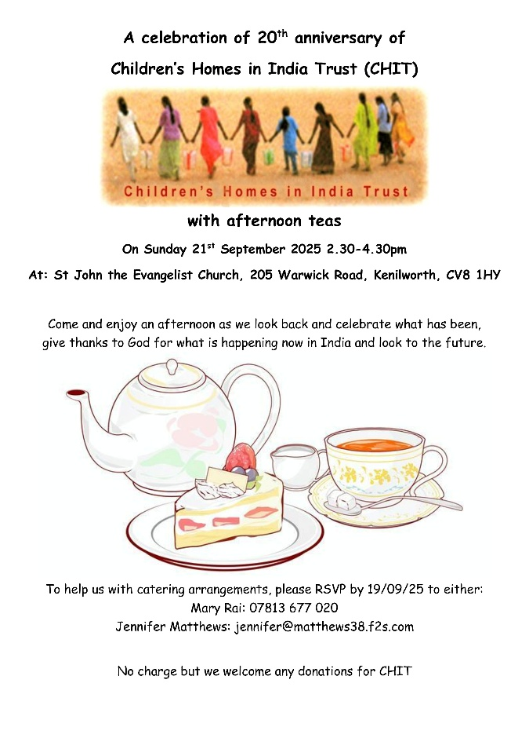

**3rd- 4th October – Learning Community 6**

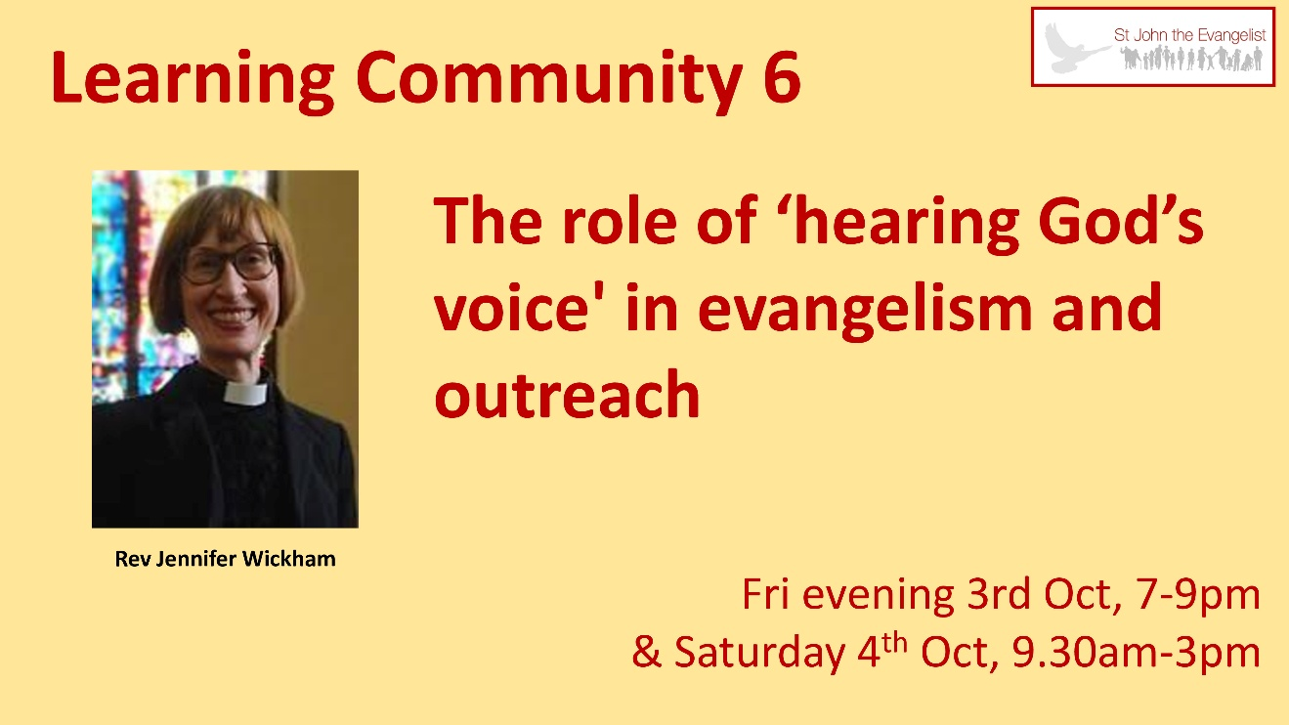

**11th October – Craft and Handmade Fair**

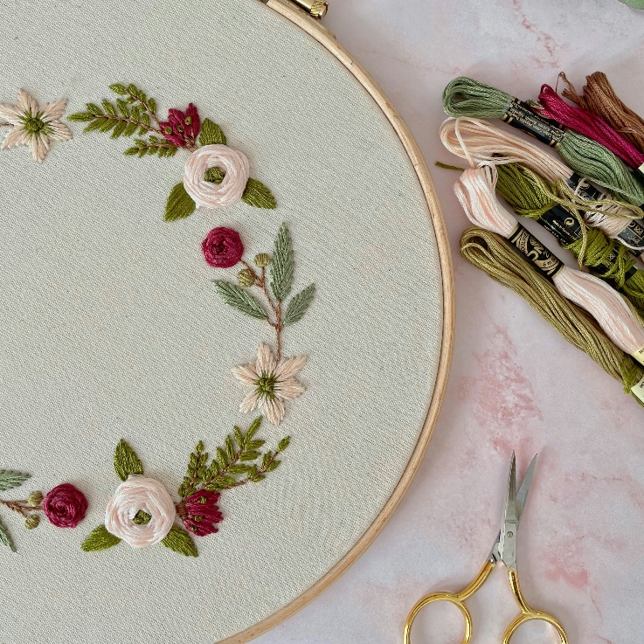

**18th October – Church Ceilidh**

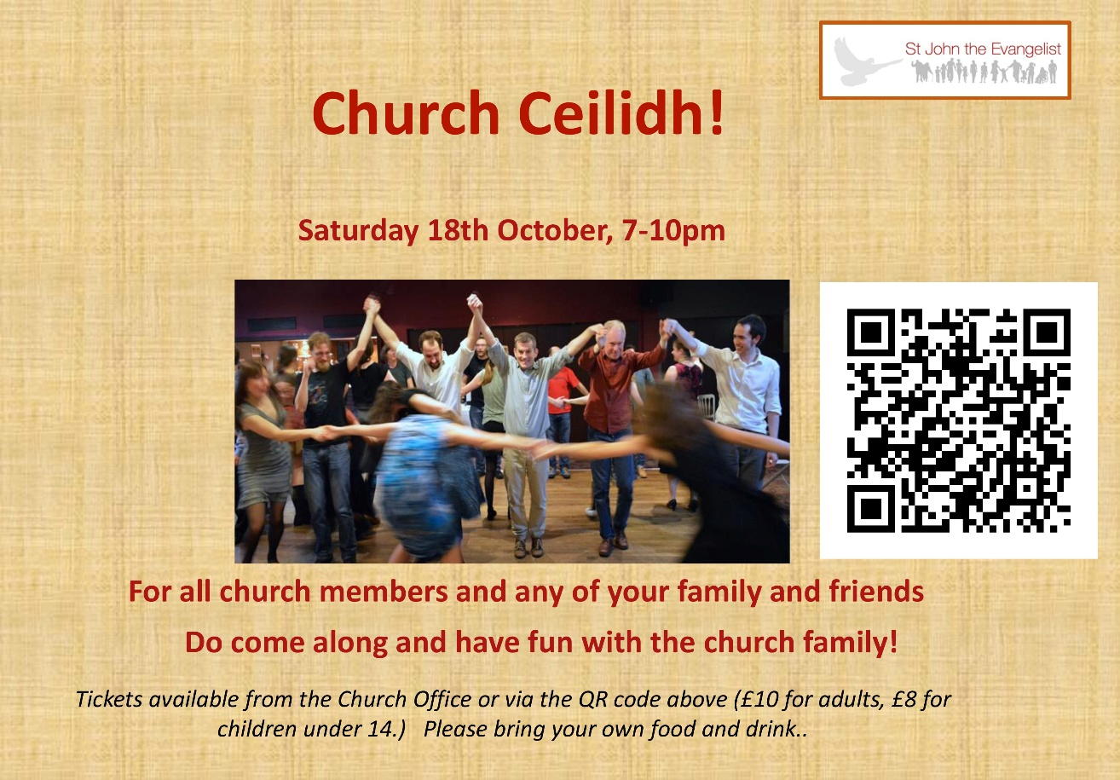

**22nd November – CHIT curry evening**

