St John the Evangelist
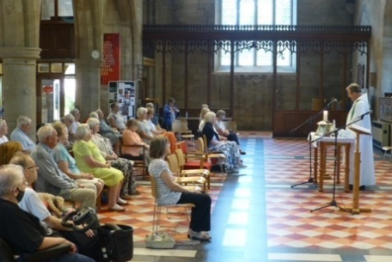
Midweek Community
Programme
May-Aug 2024

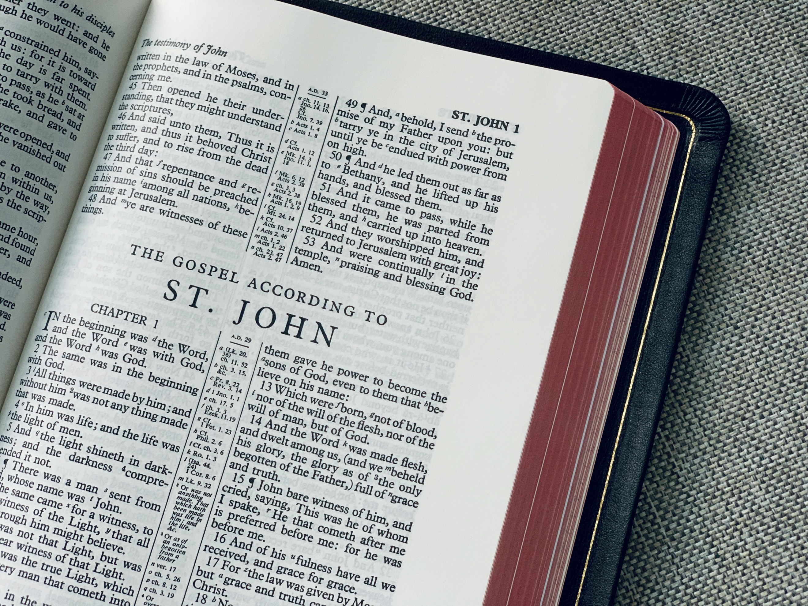

Church open from 10am
Service starts at 10.30
Theme 1: Fruit of the Spirit

May 1 Fruit of the Spirit: Love Matt 5:43-6:4
Revd. Pam Stote

May 8 Ascension Acts 1:1-11
Revd. Andrew Attwood; talk: Denise Coomber

May 15 Fruit of the Spirit: Joy Acts 16:25-34
Revd. Mary Rai

May 22 Pentecost Acts 2:1-13
Revd. Andrew Attwood

May 29 Fruit of the Spirit: Peace Phil 4:1-20
Revd. Rob Latham

June 5 Fruit of the Spirit: Patience James 5:7-11
Revd. Pam Stote

June 12 Fruit of the Spirit: Kindness Eph 4:20-5:2
Revd. Mary Rai; talk: Neswyn Firth

June 19 Fruit of the Spirit: Goodness Luke 6:27-36
Revd. Pam Stote: talk: David Hewitt

June 26 Fruit of the Spirit: Faithfulness Matt 24:36-46
Revd. Mary Rai; talk: Jane Mullaney

July 3 Fruit of the Spirit: Gentleness 1 Peter 3:13-18
Revd. Pam Stote

July 10 Fruit of the Spirit: Self-control 1 Cor 10:19-27
Revd. Rob Latham

Theme 2: Seven signs from John’s gospel

July 17 Water into wine John 2:1-11
Revd. Pam Stote; talk: Neswyn Firth

July 24 Feeding of 5,000 John 6:1-15
Agape meal
Denise Coomber; Mission prayer

July 31 Nobleman’s son John 4:46-54
Revd. Mary Rai

Aug 7 Transfiguration Mk 9:2-13
Revd. Rob Latham

Aug 14 Man at pool of Bethesda John 5:1-9, 15
Revd. Pam Stote

Aug 21 Walking on water John 6:16-21
Revd. Mary Rai; talk: Jane Mullaney

Aug 28 Healing the blind man John 9:1-12, 35-39
Neswyn Firth

Sept 5 Raising of Lazarus John 11:1-4, 32-44
Revd. Pam Stote

Who We Are
We come together to worship God and make friends of all ages.

God shows his love for us in Jesus and by the Holy Spirit.

We worship using Common Worship format and sing hymns familiar to most but sometimes we enjoy learning a less well known one.

We remain seated throughout until a time of greeting one another and fellowship at the end of the service.

Having received God’s love, we go out to share the love of Jesus with those we meet.

Find out more from:

Catherine Pennington
941209 catherineroberts49@gmail.com

David Hewitt
859798 davidhewit@gmail.com

Joan Hornsby
734410 joanhhornsby@gmail.com

Pam Stote
07708 231882 pamstote49@gmail.com

