**Forthcoming events**

**16th – 18th May – Church Weekend Away**

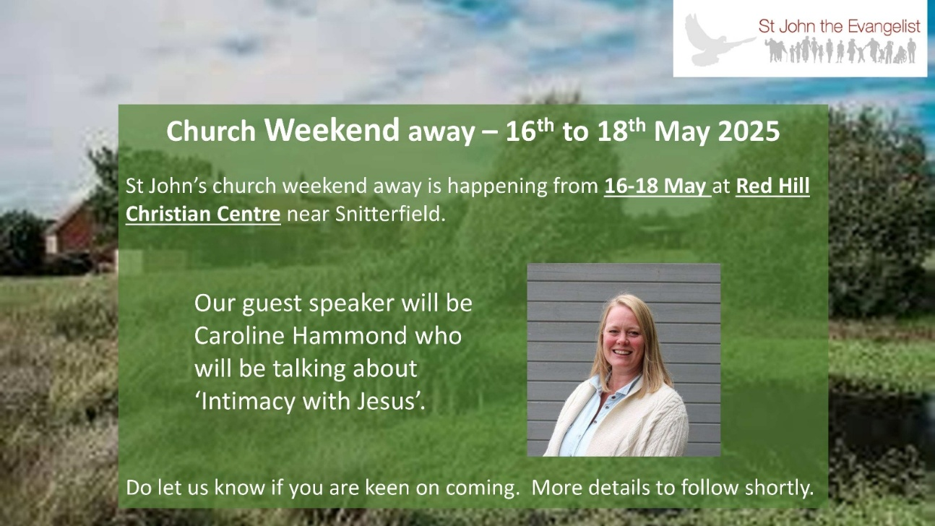

**18th October – Church Ceilidh**

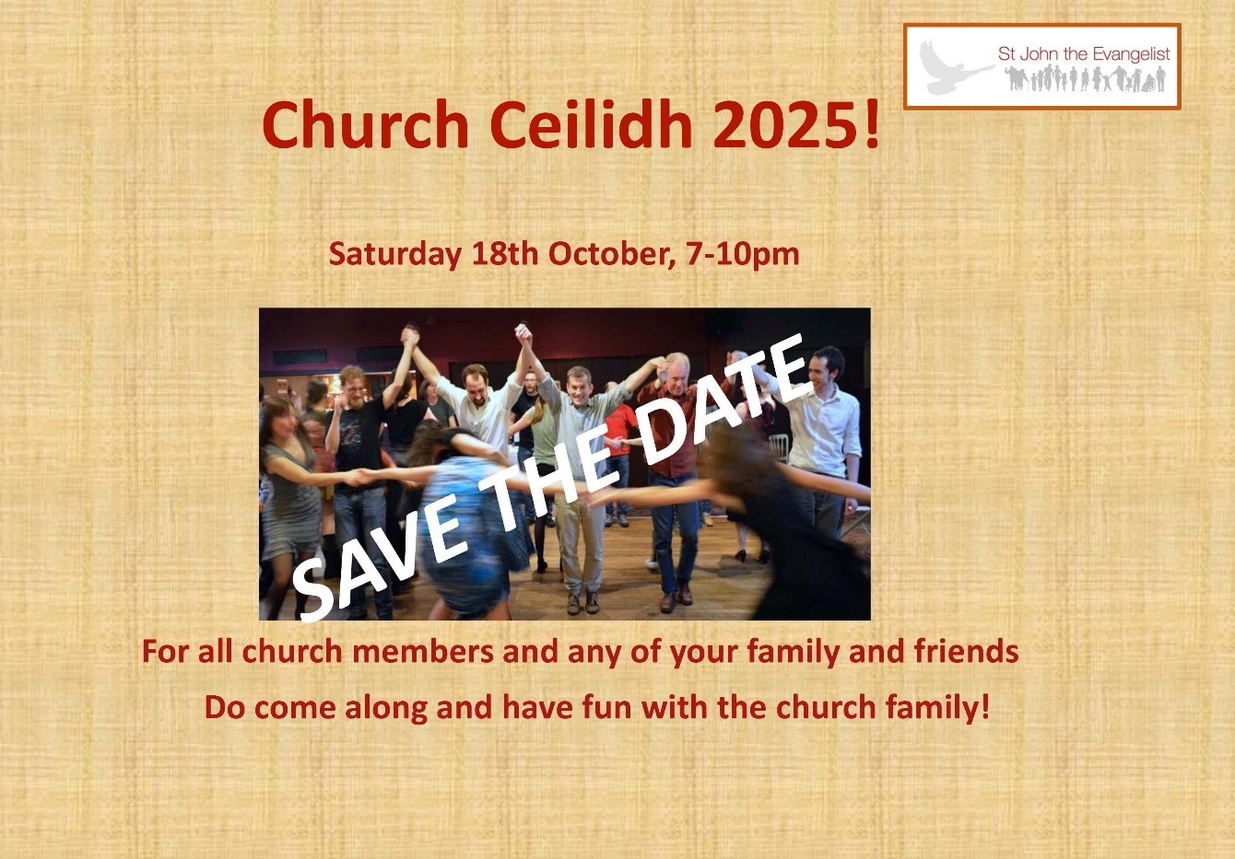

**7th-8th November – Learning Community 6**

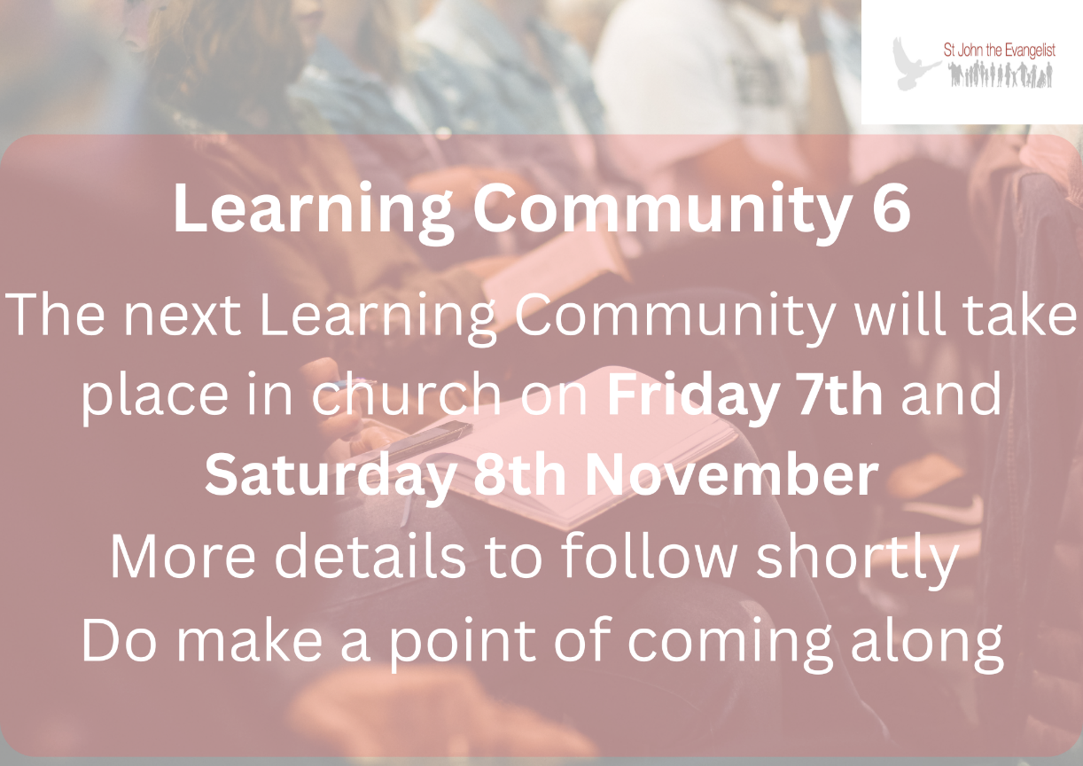

**22nd November – CHIT curry evening**

