St John the Evangelist
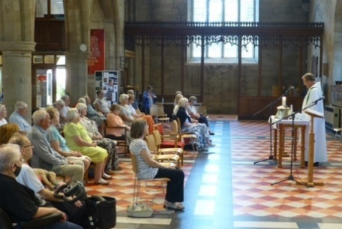
Midweek Community
Programme
Jan-Apr 2024

Church open from 10am
Service starts at 10.30
Theme 1: Treasure

Jan 3 Wise men and their treasure Is 60:1-3, 6
Revd. Mary Rai; talk: Denise Coomber Matt 2:1-12

Jan 10 God’s treasure: Israel Gen 17:1-7
Revd. Andrew Attwood Deut 7:6-9

Jan 17 Hidden treasure Prov 2:1-5
Revd. Rob Latham Matt 13:44-45

Jan 24 What and where is your Matt 6:19-21, 31-33
treasure? 1 Tim 6:17-19
Revd. Andrew Attwood

Jan 31 Our treasure: the Gospel 2 Cor 4:4-7, 16-18
Revd. Mary Rai; talk: Jane Mullaney

Feb 7 Christ is our treasure Col 2:1-3, 1:15-20
Revd. Mary Rai

Feb 14 In the wilderness Luke 4:1-13
(Ash Wednesday)
Revd. Andrew Attwood

Theme 2: At the Cross

Feb 21 A centurion finds truth Mark 15:33-39
Revd. Rob Latham

Feb 28 Joseph of Arimathea finds John 19:38-42
courage
Revd. Andrew Attwood; talk: Denise Coomber

Mar 6 Mary finds trust Luke 2:25-38
Revd. Pam Stote

Mar 13 Martha finds life John 11:17-27
Revd. Mary Rai

Mar 20 Palm Sunday Matt 21:1-11
Revd. Andrew Attwood

Mar 27 Maundy Thursday 1 Cor 15:1-11
Revd. Rob Latham John 13:1-17

Theme 3: Easter encounters

Apr 3 Breakfast on the beach John 21:1-14
Revd. Pam Stote

Apr 10 On the road to Emmaus Luke 24:13-35
Revd. Andrew Attwood

Apr 17 ‘My Lord and my God!’ John 20:19-29
Revd. Mary Rai; talk: Jane Mullaney

Apr 24 Paul, the untimely disciple 1 Cor 15:1-11
Revd. Rob Latham

You are welcome to arrive from 10am for a drink, service begins at 10.30am.
Who We Are
We come together to worship God and make friends of all ages.

God shows his love for us in Jesus and by the Holy Spirit.

We worship using Common Worship format and sing hymns familiar to most but sometimes we enjoy learning a less well known one.

We remain seated throughout until a time of greeting one another and having tea/coffee and biscuits at the end of the service.

Having received God’s love, we go out to share the love of Jesus with those we meet.

Find out more from:

Catherine Pennington
941209 catherineroberts49@gmail.com

David Hewitt
859798 davidhewit@gmail.com

Joan Hornsby
734410 joanhhornsby@gmail.com

Sam Whiteside
512261 whiteside473@btinternet.com

Pam Stote
07708 231882 pamstote49@gmail.com

