St John the Evangelist

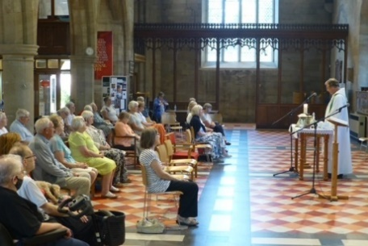
Midweek Community
Programme
September-December 2025




Church open from 10am
Service starts at 10.30am
Theme 1: We Believe…

Sept 3 God the creator Gen 1
Revd. Mary Rai

Sept 10 Uniqueness of Jesus Col 1:15-23
Revd. Andrew Attwood

Sept 17 Incarnation Jn 1:1-14
Revd. Mary Rai; talk: Jane Mullaney

Sept 24 Death & Resurrection 1 Cor 15:1-8
Revd Rob Latham

Oct 1 Return in judgement Rev 20:1-15
Revd. Pam Stote; talk: Denise Coomber

Oct 8 Harvest Lk 12:16-21
Revd. Neswyn Firth

Oct 15 Holy Spirit, giver of life Jn 3:1-8; Gen 2:4-7
Revd. Rob Latham

Oct 22 Holy catholic & apostolic church 1 Cor 12:12-14
Revd. Andrew Attwood

Oct 29 Baptism & forgiveness of sins Matt 3:13-17
Revd. Pam Stote

Nov 5 Resurrection & the life to come 1 Cor 15:50-57;
Revd. Rob Latham Heb 9:27-8 2

Nov 12 Remembrance Ex 12:14-28
Revd. Mary Rai

Theme 2: Getting ready for His coming

Nov 19 Parable of Sheep and Goats Matt 25:31-46
Revd. Andrew Attwood

Nov 26 Parable of Ten Virgins Matt 25:1-13
Revd. Pam Stote; talk: Jane Mullaney
Dec 3 Parable of Weeds Matt 13:24-30
Revd. Neswyn Firth; talk: Denise Coomber
Christmas Lunch

Dec 10 Parable of Talents Matt 25:14-30
Revd. Rob Latham

Dec 17 Carol service
Revd. Mary Rai

Dec 24 Joseph’s story Matt 1:18-25
Revd. Andrew Attwood

Who We Are
We come together to worship God and make friends of all ages.

God shows his love for us in Jesus and by the Holy Spirit.

We worship using Common Worship format and sing hymns familiar to most but sometimes we enjoy learning a less well known one.

We remain seated throughout until a time of greeting one another and fellowship at the end of the service.

Having received God’s love, we go out to share the love of Jesus with those we meet.

Find out more from:

Catherine Pennington
07717 053774 catherineroberts49@gmail.com

David Hewitt
859798 davidhewit@gmail.com

Alison Lucas
858563 alys8519@yahoo.com

Pam Stote
07708 231882 pamstote49@gmail.com

Denise Coomber
07734 489835 denisekcoomber@aol.com

